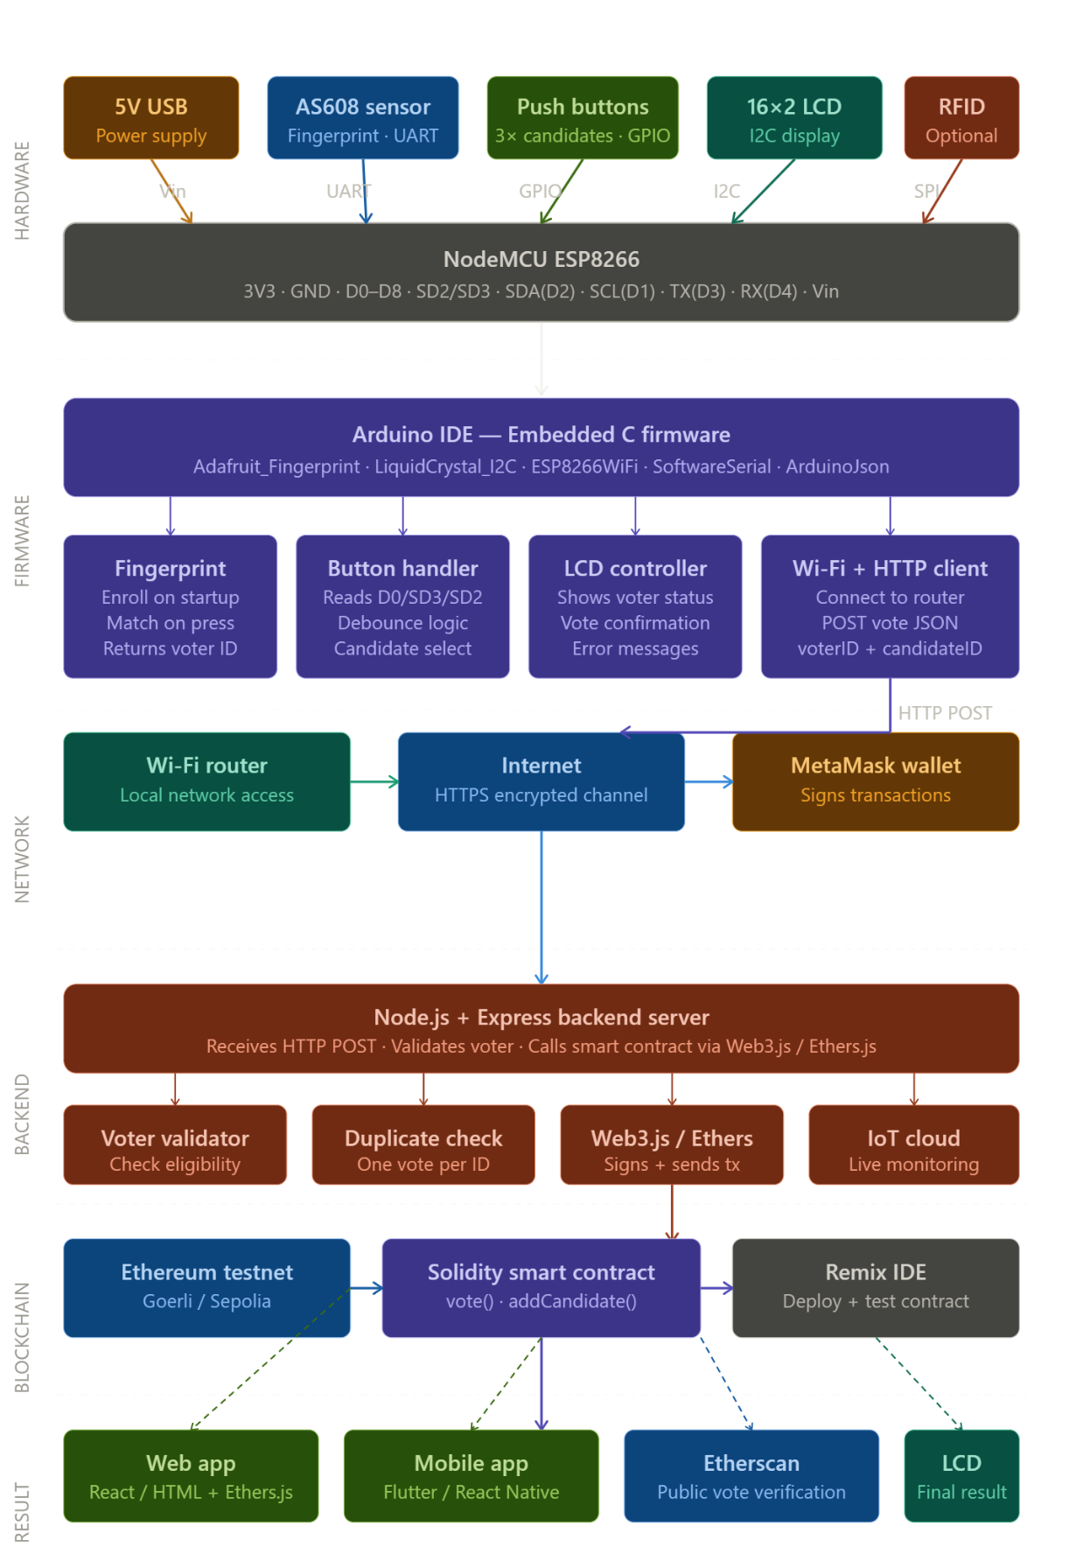
Block diagram
Circuite diagrams .
Diagram 1 — NodeMCU ESP8266 core with power supply:
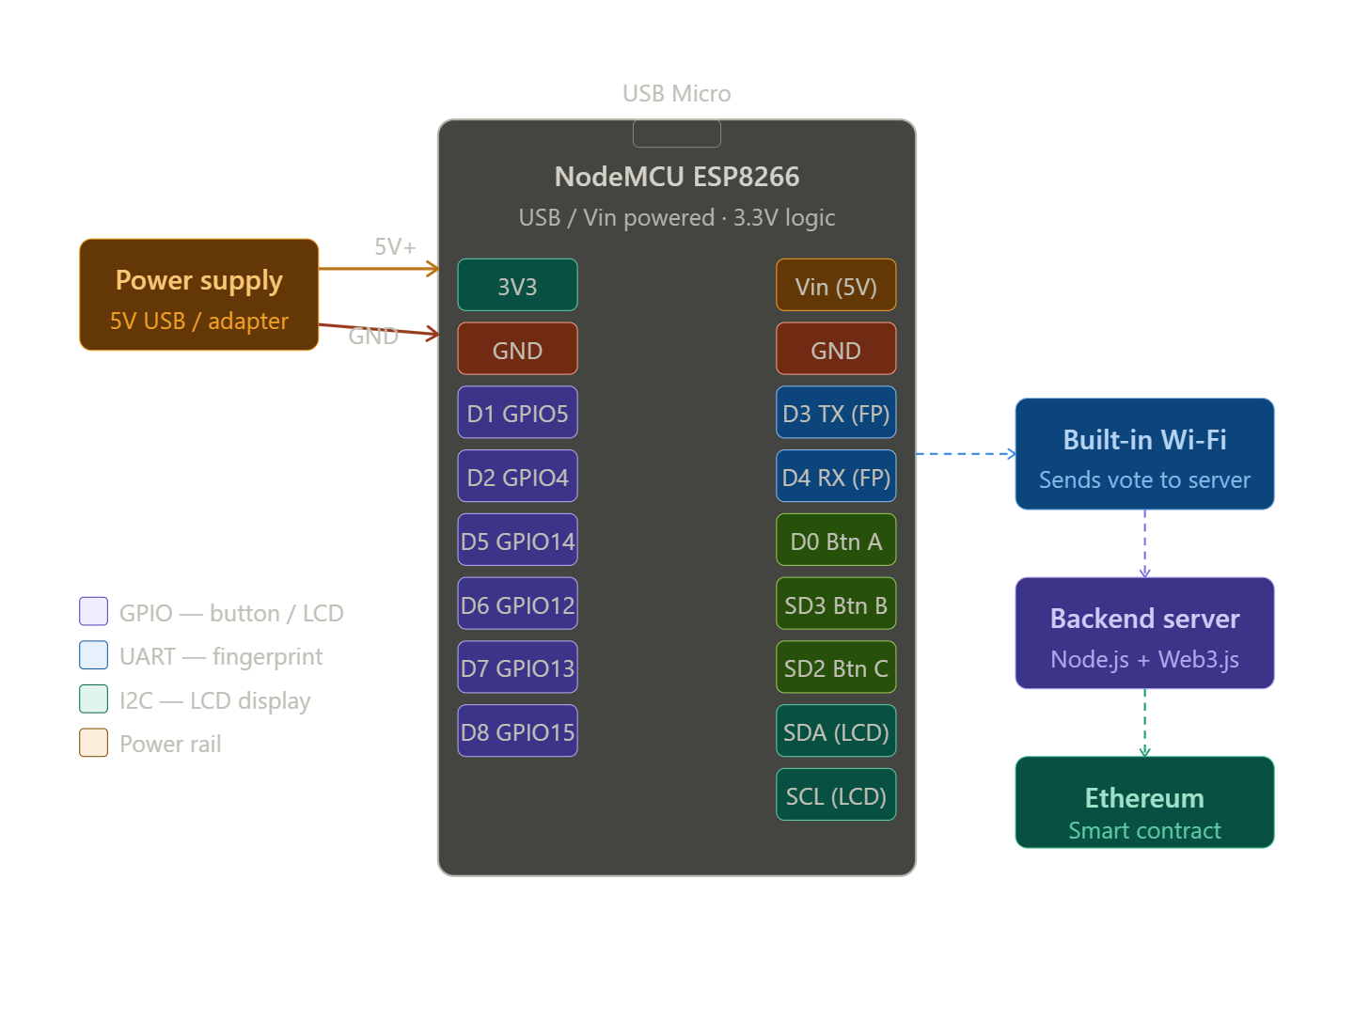
Diagram 2 — Fingerprint sensor (AS608/R305) wiring to NodeMCU:
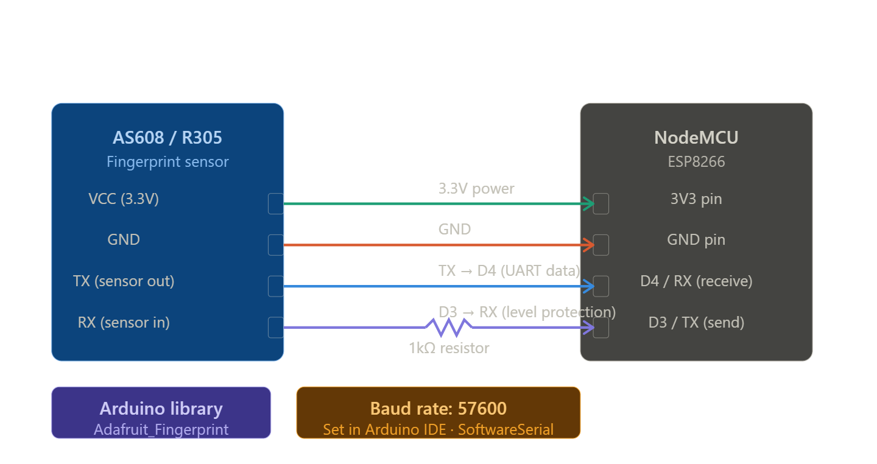
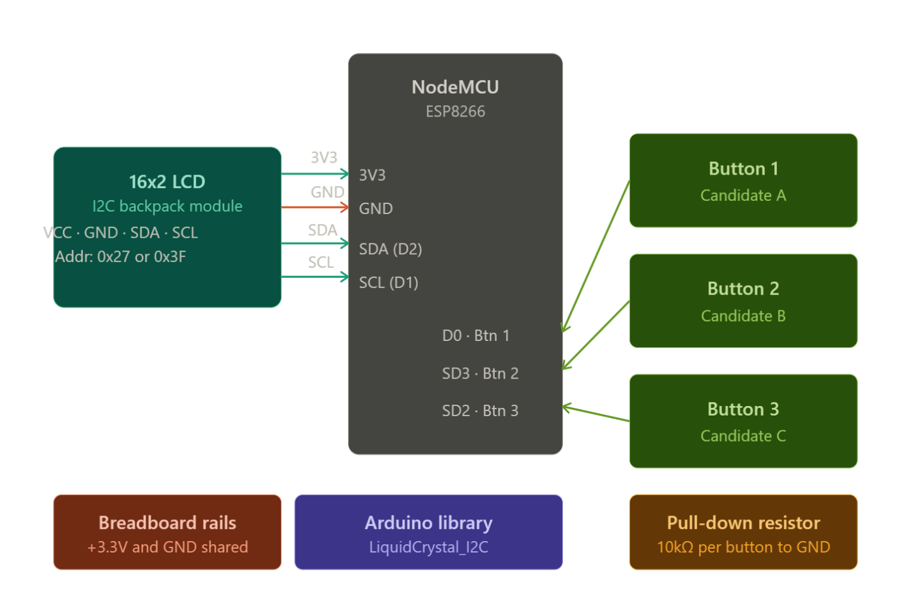
Diagram 3 — LCD display (I2C) + push buttons wiring:

